Lab Final Assessment (Project) –

Designing Subnetting with CIDR and Implementing a Network Design in CISCO Packet Tracer
Due Date: 9 a.m., Monday, 28th April, 2025

Project Guidelines and Assessment Criteria

Group Size and Contribution Policy
• Each group may consist of a maximum of 3 students.
• Every student must actively contribute to all phases: design, implementation, and reporting.
• Individual marks will be awarded based on the quality and completeness of each member’s contributions.
• Students must clearly mention their individual contributions in the final report under a 'Team Contribution' section.
• Incomplete or undocumented contributions may result in partial or no marks for that section.
Assessment Criteria: Q&A; zero credit will be awarded in case of a no show for the Q&A session.
Deliverables:
- A complete report with analysis, screenshots and routers’ configurations.
- Labelled CISCO Packet Tracer File containing full working implementation of the project.

Assessment Breakdown
Assessment Rubric | Marks | Evaluation Criteria | Name:  Student ID: | Name:  Student ID: | Name:  Student ID:
Design a solution for a computing system | 5 | - Design a subnetting strategy: accurate calculation of subnets, host ranges, and subnet mask  - Correct use of IPs, design interface setup, and end-to-end reachability
Generates a problem solution | 10 | - Implement subnetting in Packet Tracer: correct IP usage, interface setup, and reachability  - Configure RIP or OSPF: protocol setup and routing table verification  - Verify connectivity: successful ping tests and complete routing table output  - Document project: structured report with screenshots, subnet tables, and configs

Assessment Rubrics
Assessment Criteria | Unsatisfactory (1-4) | Needs Improvement  (5-6) | Meets Expectations  (6-8) | Exceeds Expectations  (9-10)
Design a solution for a computing system | The solution lacks coherence or clarity, with insufficient detail provided to understand how the computing system will be designed. Key components or requirements may be missing, and the proposed solution may not address the problem effectively. | The solution outlines a basic plan for designing the computing system but lacks depth or sophistication. Some components may be poorly defined or require further elaboration to fully understand their function within the system. More detail and refinement are needed to enhance the quality and feasibility of the solution. | The solution provides a well-thought-out plan for designing the computing system, including key components, requirements, and implementation strategies. The proposed solution addresses the problem effectively and demonstrates a clear understanding of the system's architecture and functionality. | The solution offers a comprehensive and innovative approach to designing the computing system, incorporating advanced techniques or technologies to optimize performance and functionality. The proposed solution is well-documented and supported by evidence, demonstrating a thorough analysis of the problem and potential design considerations.
Generates a problem solution | The problem solution is unclear or poorly defined, with insufficient detail provided to understand how the problem will be addressed. Key aspects of the solution may be missing or inadequately explained, and it may not effectively resolve the underlying problem. | The problem solution outlines a basic approach to addressing the problem but lacks depth or specificity. Important details may be overlooked, and the proposed solution may not fully resolve the underlying issues or challenges. Further refinement and elaboration are needed to enhance the effectiveness of the solution. | The problem solution presents a well-defined and coherent approach to addressing the problem, including clear objectives, strategies, and implementation steps. The proposed solution demonstrates a thorough understanding of the problem and offers a feasible plan for resolution. | The problem solution offers an innovative and comprehensive approach to addressing the problem, incorporating advanced strategies or techniques to optimize effectiveness and efficiency. The proposed solution is well-supported by evidence and demonstrates a high level of creativity and ingenuity in problem-solving.

Introduction -

Designing Subnetting with CIDR and Implementing a Network Design in CISCO Packet Tracer
Imagine you’ve just been hired as a network designer at a growing organization. Your first big task: design a scalable and efficient IP addressing scheme for the company’s expanding infrastructure!
You will be responsible for dividing a given IP block into subnetworks for various departments across the organization. You get to name and number the departments (e.g., Department 1: HR, Department 2: IT, Department 3: Research, etc.).
You must carefully design your subnets based on the unique requirements assigned to your team, and then implement your design in Cisco Packet Tracer using dynamic routing protocols to simulate a fully functional network. This project is your chance to apply what you've learned and show your skill in real-world network design!

Objective
- Design and implement a subnetting strategy using CIDR to divide a given IP block into equal-sized subnets based on team-specific requirements.
- Configure a network topology in Cisco Packet Tracer with 5–8 subnets, two or more PCs per subnet.
- Configure routers with a dynamic routing protocol (RIP or OSPF).
- Capture all configurations and tests using annotated screenshots.
- Imagine you’ve just been hired as a network designer at a growing organization. Your first big task: design a scalable and efficient IP addressing scheme for the company’s expanding infrastructure!

Subnetting Rules Based on Student IDs:
Enter the right most 3-digits of the student IDs. Read the rules after the table.
 | Sum of the three single digit numbers gives the number of subnets to create | The largest two digit number gives the minimum number of hosts required per subnet
Students Information | 3rd last digit of the student ID | 2nd last digit of the student ID | Rightmost digit of the Student ID
Group Member 1  202200002458 | 4 | 5 | 8
Group Member 2  20210001983 | 9 | 8 | 3
Group Member 3  20230002900 | 9 | 0 | 0
 | Total Subnets: 22 | Max of 3 values gives you the min. # of hosts per subnet: 83
- Sum of the leftmost digits of the three group members' student IDs = Number of required subnets (LANs).
- Highest value among the last two digits of all three IDs = Minimum number of hosts required per subnet.
- All subnets can be of equal-size.

Example
Student IDs: 252398, 353112, 751205
- Sum of 3rd last digits: = 3+1+2 =6 subnets required
- Highest rightmost two digits: max(98, 12, 05) = 98 hosts/subnet
- Choose the Given IP Addresses block Accordingly from Class A, B, or C.

DEPARTMENTS:
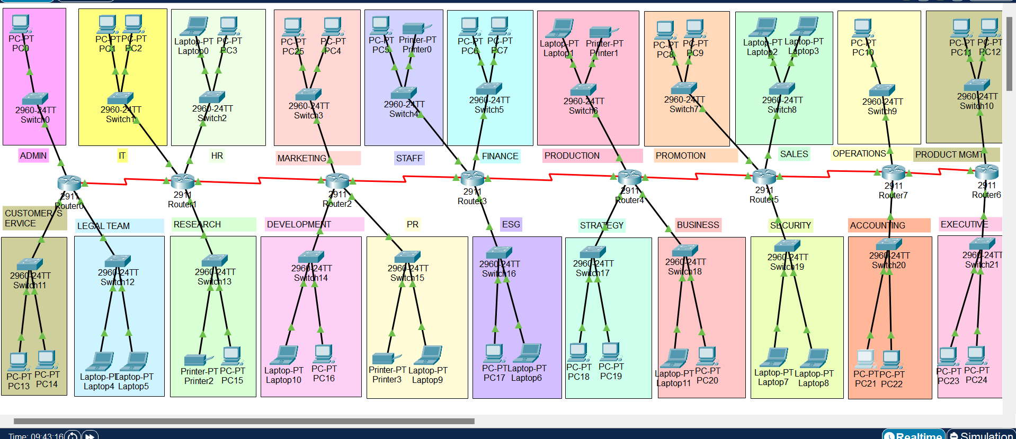

1. Subnet Design Summary
Design Parameter | Value
Total Subnets (based on ID rule) | 22
Minimum Hosts/Subnet | 83
Chosen CIDR Block | 172.20.0.0/25
Subnet Mask | 255.255.255.128
Total IPs per Subnet | 128
Usable Hosts per Subnet | 128-2 = 126
Total IPs Needed | 22*83 = 1826
Address Block Justification | Used class B block, borrowed 5 bits for subnetting from host portion, and left 7 bits for host to reduce IP wastage while also leaving room for growth.

2. Subnet Addressing Table (first 5–8 subnets)
Subnet | Subnet Address | First Usable IP | Last Usable IP | Broadcast Address
Subnet 1 | 172.20.0.0 | 172.20.0.1 | 172.20.0.126 | 172.20.0.127
Subnet 2 | 172.20.0.128 | 172.20.0.129 | 172.20.0.254 | 172.20.0.255
Subnet 3 | 172.20.1.0 | 172.20.1.1 | 172.20.1.126 | 172.20.1.127
Subnet 4 | 172.20.1.128 | 172.20.1.129 | 172.20.1.254 | 172.20.1.255
Subnet 5 | 172.20.2.0 | 172.20.2.1 | 172.20.2.126 | 172.20.2.127
Subnet 6 | 172.20.2.128 | 172.20.2.129 | 172.20.2.254 | 172.20.2.255
Subnet 7 | 172.20.3.0 | 172.20.3.1 | 172.20.3.126 | 172.20.3.127
Subnet 8 | 172.20.3.128 | 172.20.3.129 | 172.20.3.254 | 172.20.3.255

3. Packet Tracer Implementation
Implement your designed subnets in Cisco Packet Tracer. Each subnet must include at least two end devices (e.g., PCs), and all routers must be configured to interconnect subnets. Use either RIP or OSPF as the dynamic routing protocol. Ensure all routing tables are updated correctly.

4. Configuration Summary Table

Device | Interface | Assigned IP Address | Subnet
Router1 | GigabitEthernet 0/0 | 172.20.0.1/25 | 172.20.0.0
Router1 | GigabitEthernet 0/1 | 172.20.0.129/25 | 172.20.0.128
Router1 | GigabitEthernet 0/2 | 172.20.1.1/25 | 172.20.1.0
Router1 | Serial0/3/0 | 172.20.50.1/30 | 172.20.50.0
Router2 | GigabitEthernet 0/0 | 172.20.2.1/25 | 172.20.2.0
Router2 | GigabitEthernet 0/1 | 172.20.2.129/25 | 172.20.2.128
Router2 | GigabitEthernet 0/2 | 172.20.3.1/25 | 172.20.3.0
Router2 | Serial0/3/0 | 172.20.50.2/30 | 172.20.50.0
Router2 | Serial0/3/1 | 172.20.50.5/30 | 172.20.50.4
Router 3 | GigabitEthernet 0/0 | 172.20.4.129/25 | 172.20.4.128
Router 3 | GigabitEthernet 0/1 | 172.20.5.1/25 | 172.20.5.0
Router 3 | GigabitEthernet 0/2 | 172.20.5.129/25 | 172.20.5.128
Router 3 | Serial0/3/0 | 172.20.50.9/30 | 172.20.50.8
Router 3 | Serial0/3/1 | 172.20.50.6/30 | 172.20.50.4
Router 4 | GigabitEthernet 0/0 | 172.20.7.1/25 | 172.20.7.0
Router 4 | GigabitEthernet 0/1 | 172.20.7.129/25 | 172.20.7.128
Router 4 | GigabitEthernet 0/2 | 172.20.8.1/25 | 172.20.8.0
Router 4 | Serial0/3/0 | 172.20.50.10/30 | 172.20.50.8
Router 4 | Serial0/3/1 | 172.20.50.13/30 | 172.20.50.12
Router 5 | GigabitEthernet 0/0 | 172.20.9.129/25 | 172.20.9.128
Router 5 | GigabitEthernet 0/1 | 172.20.10.1/25 | 172.20.10.0
Router 5 | GigabitEthernet 0/2 | 172.20.10.129/25 | 172.20.10.128
Router 5 | Serial0/3/0 | 172.20.50.17/30 | 172.20.50.16
Router 5 | Serial0/3/1 | 172.20.50.14/30 | 172.20.50.12
Router 6 | GigabitEthernet 0/0 | 172.20.12.1/25 | 172.20.12.0
Router 6 | GigabitEthernet 0/1 | 172.20.12.129/25 | 172.20.12.128
Router 6 | GigabitEthernet 0/2 | 172.20.13.1/25 | 172.20.13.0
Router 6 | Serial0/3/0 | 172.20.50.18/30 | 172.20.50.16
Router 6 | Serial0/3/1 | 172.20.50.21/30 | 172.20.50.20
Router 7 | GigabitEthernet 0/0 | 172.20.14.129/25 | 172.20.14.128
Router 7 | GigabitEthernet 0/1 | 172.20.15.1/25 | 172.20.15.0
Router 7 | GigabitEthernet 0/2 | 172.20.15.129/25 | 172.20.15.128
Router 7 | Serial0/3/0 | 172.20.50.25/30 | 172.20.50.24
Router 7 | Serial0/3/1 | 172.20.50.22/30 | 172.20.50.20
Router 8 | GigabitEthernet 0/0 | 172.20.17.1/25 | 172.20.17.0
Router 8 | GigabitEthernet 0/1 | 172.20.17.129/25 | 172.20.17.128
Router 8 | Serial0/3/0 | 172.20.50.26/30 | 172.20.50.24

5. Dynamic Routing Configuration (RIP or OSPF) : RIP
Summarize your dynamic routing configuration using commands and include screenshots.
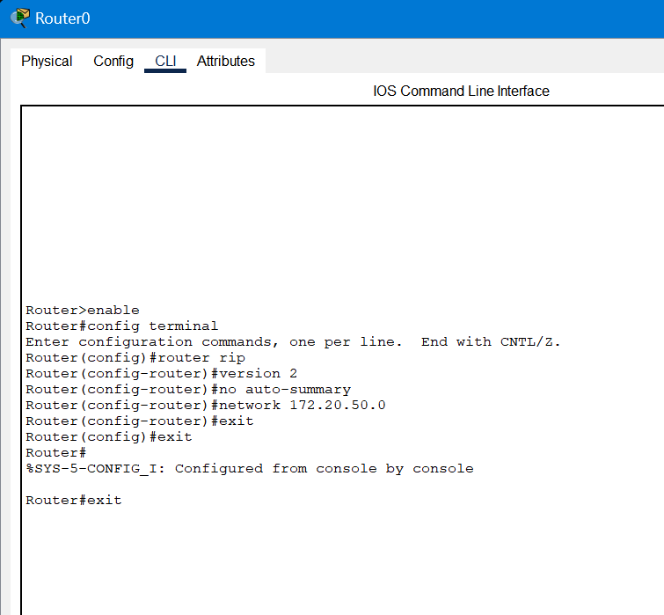
- We used RIPv2(for classless dynamic routing) to connect all 8 routers, we established connections between 2 neighbouring routers using the subnet 172.20.50.0/30. This allowed us to prevent wastage of ips as only 2 usable ips in this subnet and that’s between the routers.

6. Connectivity Testing and Verification
Include ping test results, routing tables (`show ip route`), and traceroutes between subnets.
ROUTING TABLES:
ROUTER 0
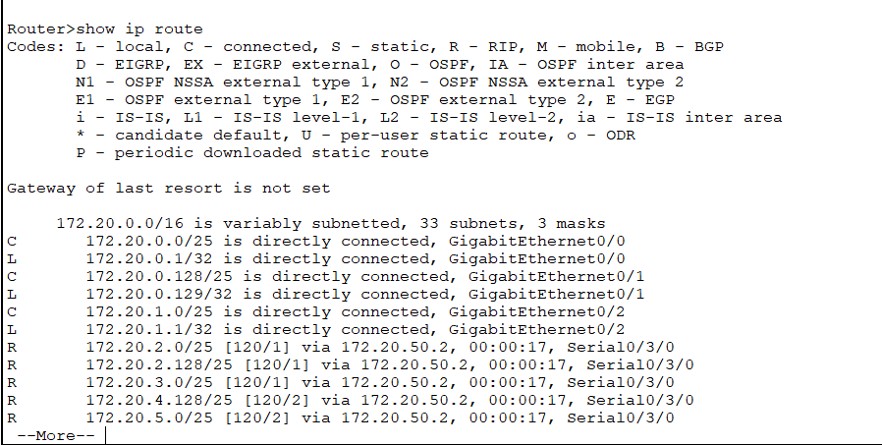

ROUTER 1
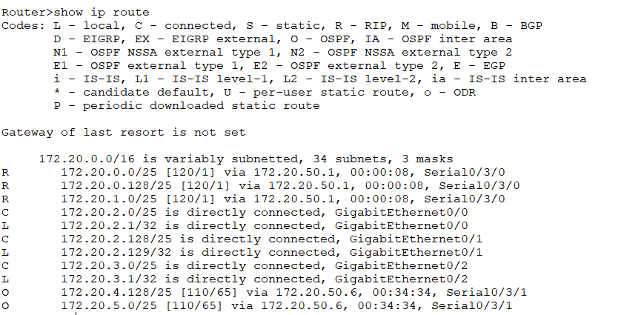
ROUTER 2
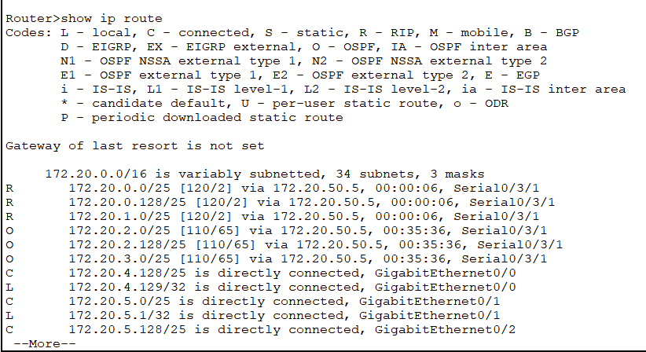
ROUTER 3
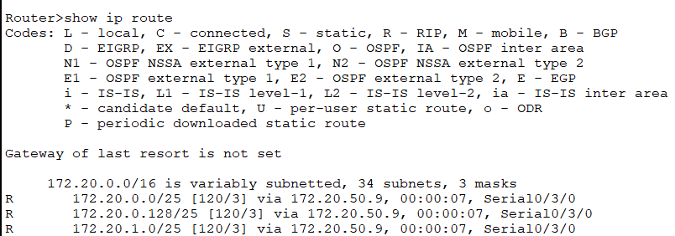

ROUTER 4
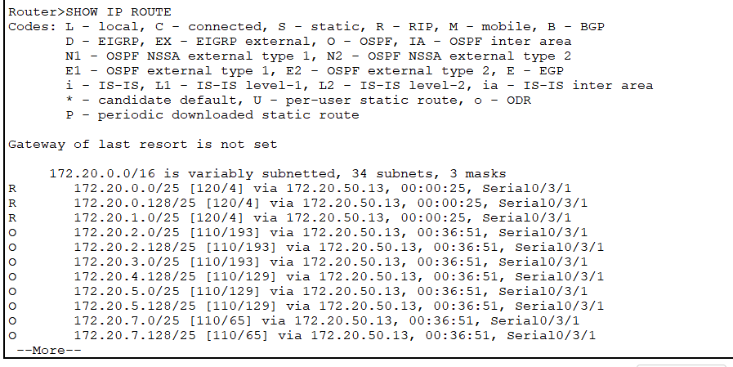
ROUTER 5
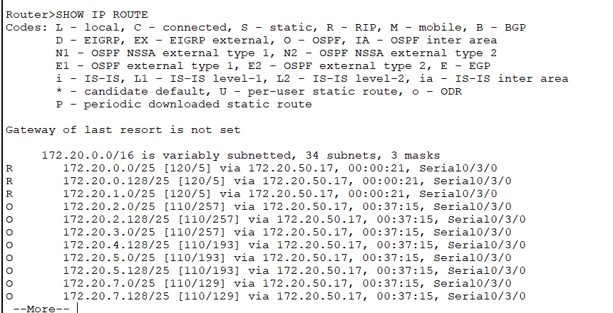
ROUTER 7
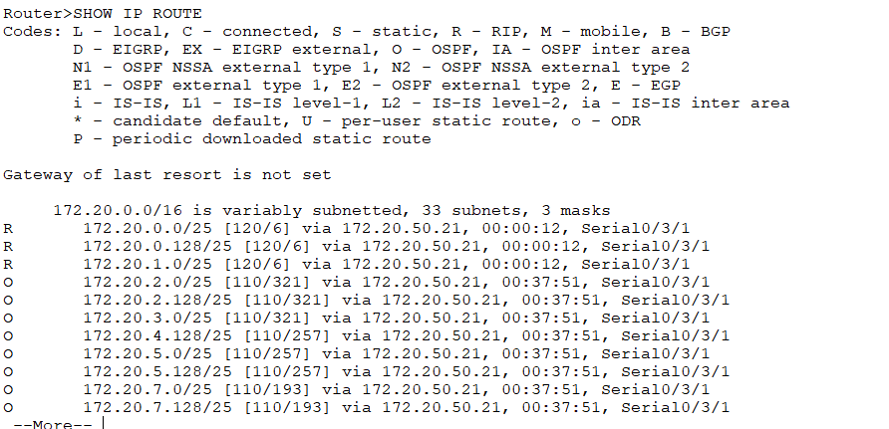

ROUTER 6
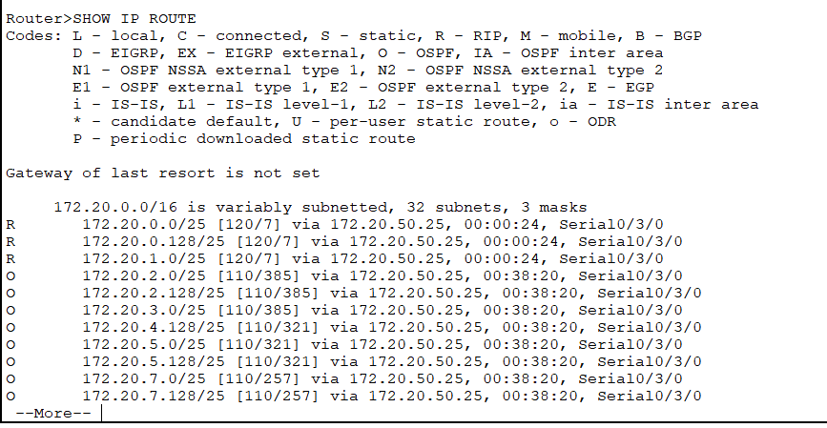

PING TEST:
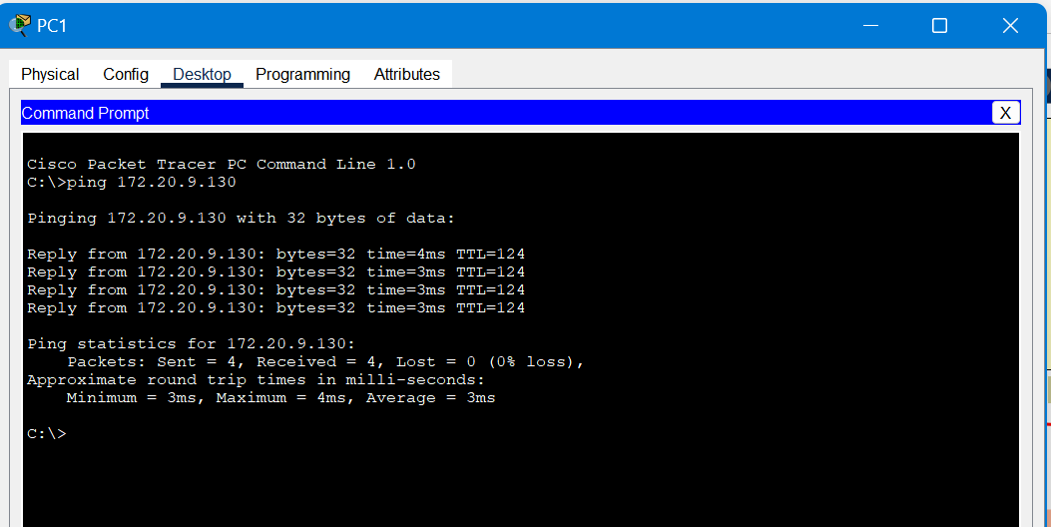
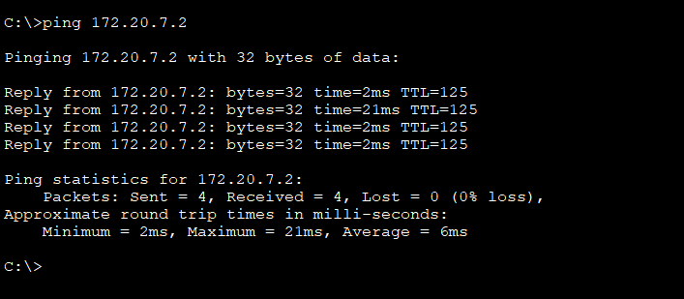
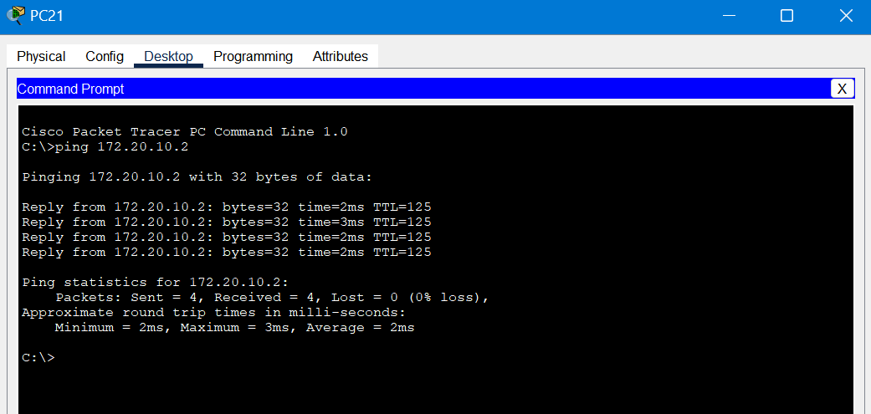
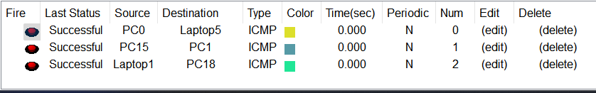

TRACE ROUTE:
ROUTER TO PC:
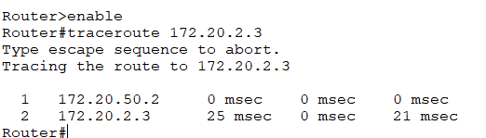

PC TO PC:
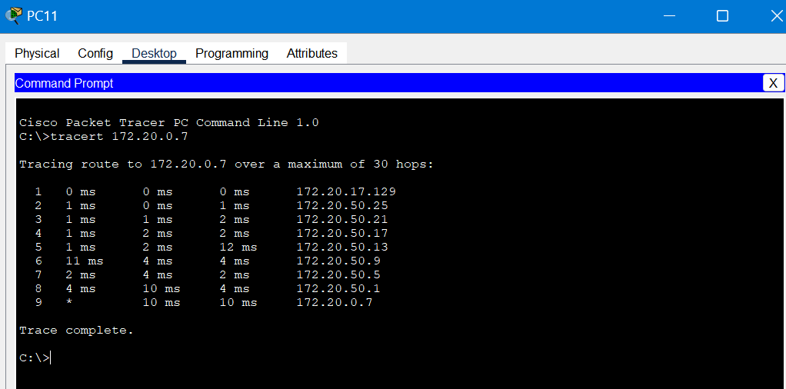
8. Export Router Configurations, and paste them below. (click on every router, and click on the export button to extract its configurations)
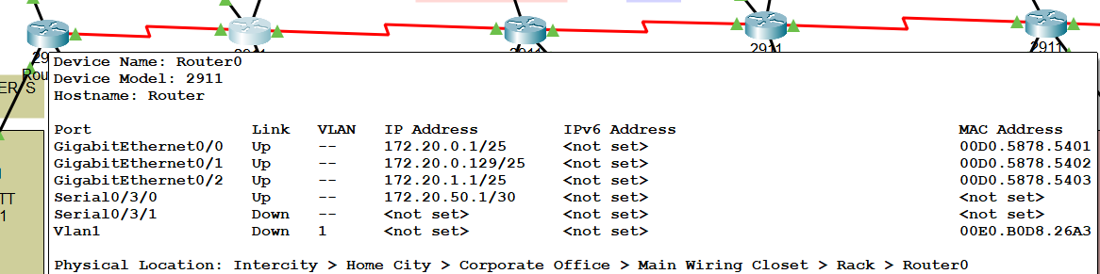
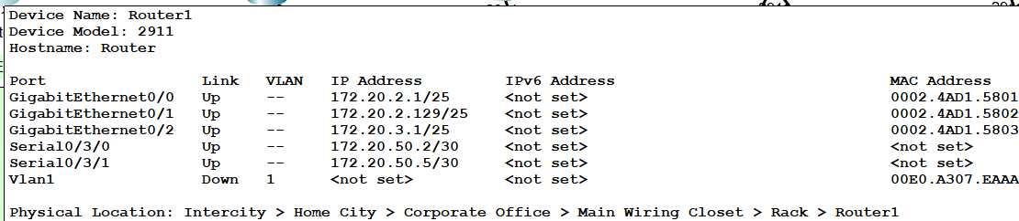
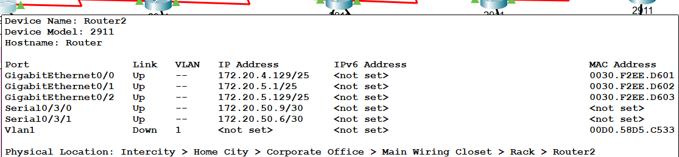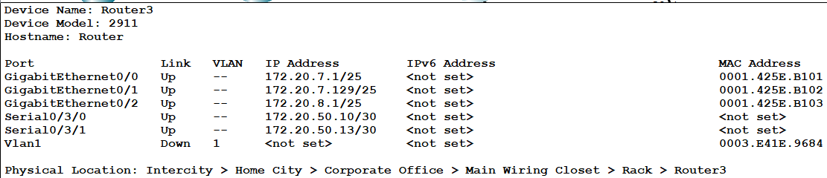
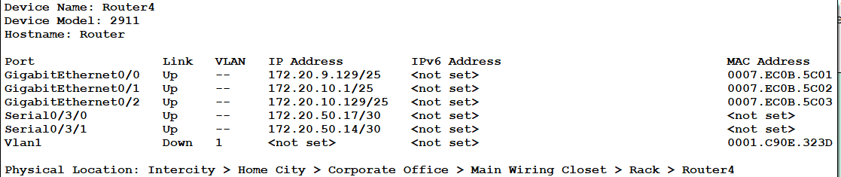
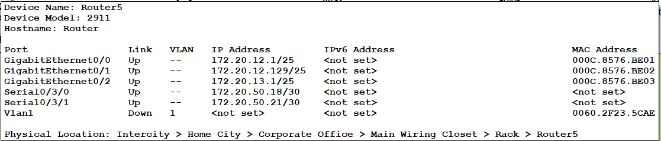
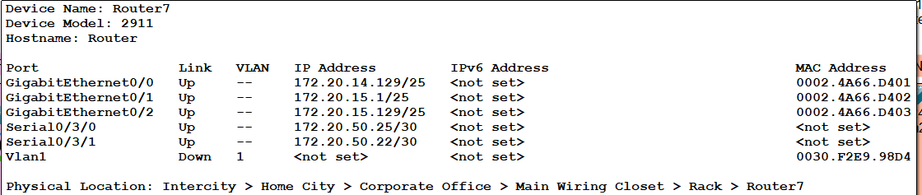
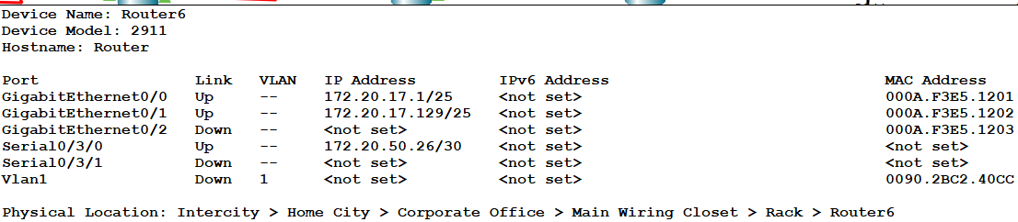

CONTRIBUTION:
JANA MAHMOUD(20230002900): subnetted a class B block into 22 subnets using the student ids and provided screenshots for ping tests.
AYSHA EJAZ(20220002458): implemented the network on cisco packet tracer, helped with rip routing and provided screenshots for routing table
LEANNE RODRIGO(20210001983): implemented the RIP dynamic routing on the routers and provided screenshots for router configurations.

